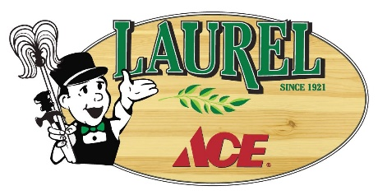
Alameda County Beekeepers, Alameda County Clean Water Program/Our Water Our World, team up with Laurel Ace September 29 & 30 for inaugural Fall Pollinator Event

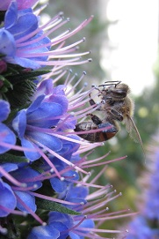
Oakland, CA, September 18, 2018 – Activities will be buzzing around Laurel Ace the weekend of September 29 & 30 as volunteers from The Alameda County Beekeepers Association join The Laurel’s Mom & Pop hardware store for Laurel Ace’s first ever Fall Pollinator Event. From 8am-6pm on September 29 & 30, Laurel Ace invites their neighbors to shop the garden center’s huge supply of pollinator friendly, drought tolerant, neonicotinoid-free plants, and to enjoy related bee education and observation activities and local honey sales. 20% of all plant and seed sales that weekend will be donated to Oakland’s Pollinator Posse.
Our Water Our World will be on hand Saturday from 11-3 to answer questions about pollinator-friendly garden products and to find environmentally-friendly solutions to your projects. Volunteers from the Alameda County Beekeepers Association will be on hand from 11-3 Sunday to talk to customers about bees and planting pollinator-friendly flowers from which to forage over the winter. They will also bring an observation hive, and will have five flavors of local honey for tasting, and for sale.
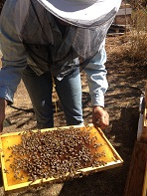
Laurel Ace strongly opposes the use of pesticides containing neonicotinoids, a systemic insecticide which have been linked to the international bee Colony Collapse Disorder (CCD). All of Laurel Ace's plants are proudly neonic-free. Laurel Ace and their brother store Marin Ace in San Rafael have been working with Ace Hardware on a national basis to raise awareness of CCD attributed to neonics, with outreach, product changes, and education now taking place throughout all the 5,000+ locally-owned stores in the US.
Laurel Ace is locally owned by Michelle and Jeff Leopold, and business partner Troy Welch, and were grateful to take over ownership of this beloved 1921 landmark Oakland hardware store in April 2017.
“We’re delighted to have had four successful annual Fall Pollinator events at our San Rafael Store, Marin Ace” shared Michelle. “We have raised awareness of the importance of planting plants that bloom over the winter to our Marin customers. Now with the addition of our garden center at our newest, oldest store in Oakland, we look forward to helping pollinators in Oakland with an annual Fall Pollinator Event at Laurel Ace.”

HOW DID LAUREL ACE GET INVOLVED IN HELPING OUR POLLINATORS?
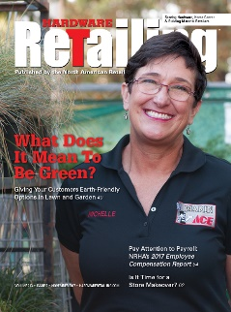
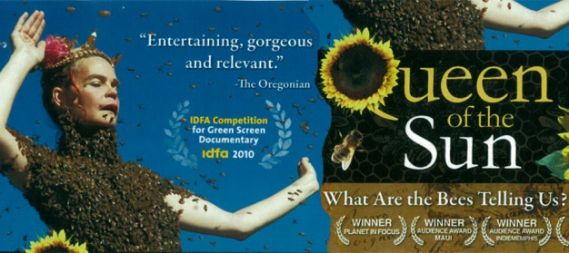
“Mom” Michelle Leopold saw a screening of the Queen of the Sun documentary six years ago, and was immediately moved to action in stopping the use of Neonicotinoids at her (then) two stores. As the owner of local Ace Hardware stores in the SF Bay Area, Michelle knew she could make a difference, and immediately made sure that the plants that they were selling were neonic-free. (They were.) Since then, she has labeled the pesticides containing neonics “harmful to pollinators” and continues to work closely with the Our Water Our World program at all three of their Ace stores. She has also worked with the national buyers at Ace Hardware’s corporate office in raising awareness throughout the 5,000+ locally-owned Ace Hardware stores of the harmfulness of neonics to pollinators, and was delighted when the national plant vendor for the Ace co-op changed in 2014 to neonic-free plants, a change other “big box” stores have been unable to make as of today. As a leader of Ace stores’ move away from neonicotinoids, Michelle’s actions were featured in the cover story of Hardware Retailing’s 11/17 article “What Does It Mean To Be Green?”, and she was cited in the 5/15 TakePart.com article when Ace Hardware announced that they would move away from products and plants containing neonics.

POLLINATOR POSSE:
20% of all live good purchases (plants and seeds) sold during the Fall Pollinator Event will be donated to Oakland’s Pollinator Posse. The Pollinator Posse’s mission is to create pollinator-friendly landscaping and to foster appreciation of local ecosystems through outreach, education and direct action. With eco-friendly landscape techniques at the heart of their work, they teach respect for the creatures which keep Oakland– and the world– blooming. The Alameda County Beekeepers participating in the event selected this non-profit because of their work in Oakland’s many neighborhoods – especially in the garden-friendly “banana belt” neighborhood of The Laurel. For more information, visit pollinatorposse.org
# # #

Laurel Ace
Location: 4024 MacArthur Blvd.,
Oakland CA 94619
in The Laurel
Phone/Text: 510/530-1966
Website: LaurelAce.com
Store hours: M-F 7-7, S-S 8-6

Fall Pollinator Event Questions:
Michelle Leopold
Owner/Marketing & Charitable Contributions
415-302-4055
Michelle@LaurelAce.com
Outside Participants at the Fall Pollinator Event:
(Saturday 11-3) Lisa Ratusz, Our Water Our World/Alameda County Clean Water
(Sunday 11-3) Ronni Brega and Pam Weimer, Alameda County Beekeepers Association

